1. **Sign in to AWS Console:**
   * Go to the [AWS Management Console](https://aws.amazon.com/console/).
   * Sign in with your AWS credentials.
2. **Navigate to S3:**
   * In the AWS Console, search for **S3** in the search bar and select **S3** from the list.

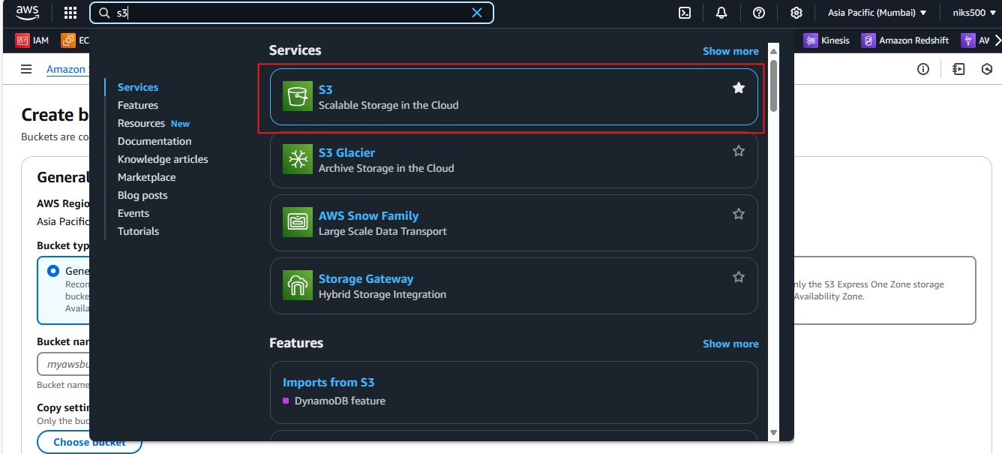

1. **Select Your Bucket:**
   * In the S3 dashboard, click on the name of the bucket where you want to set up the lifecycle policy.

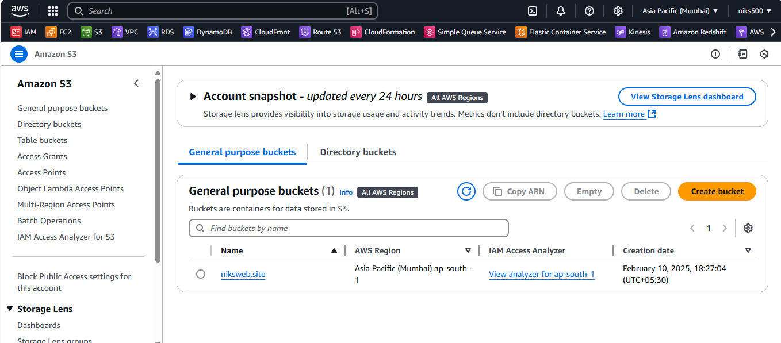

1. **Go to Management Tab:**
   * In the bucket dashboard, go to the **Management** tab.

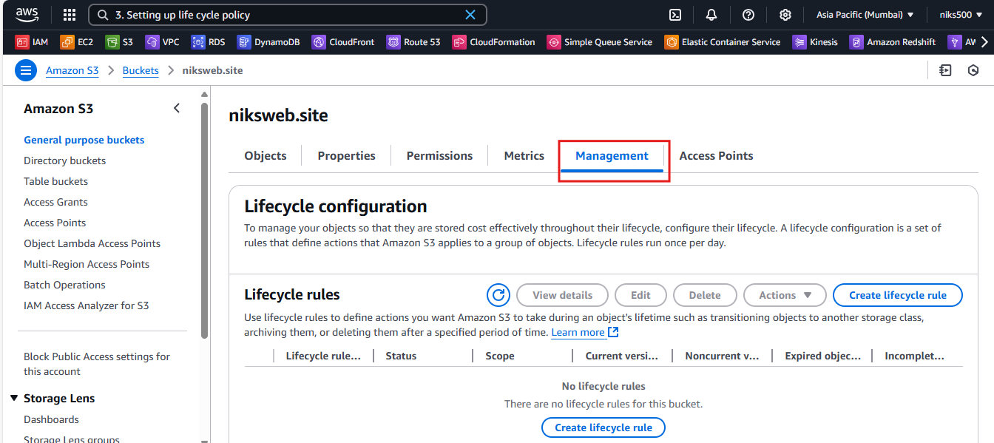

1. **Add Lifecycle Rule:**
   * Under **Lifecycle rules**, click **Create lifecycle rule**.

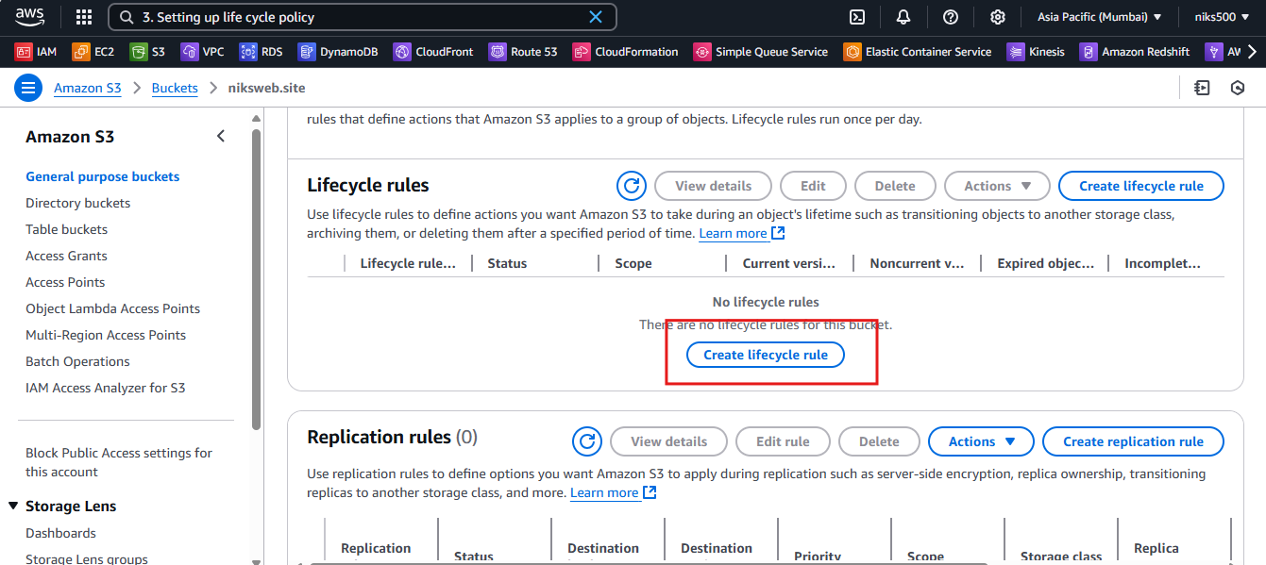

1. **Configure Rule:**
   * **Rule Name:** Provide a meaningful name for your rule (e.g., Move to Glacier after 30 days).
   * **Scope:** You can apply the rule to all objects in the bucket or specify a prefix or tags to limit which objects the rule will apply to.

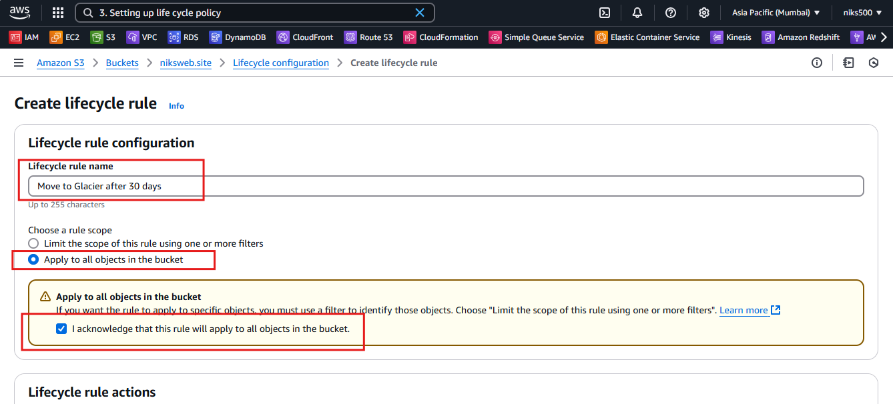

1. **Set Transition Actions:**
   * **Transition to another storage class**: Choose a storage class to transition objects to after a certain time (e.g., **S3 Glacier**, **S3 Intelligent-Tiering**, or **S3 Standard-IA**).
     + Example: Transition objects to **S3 Glacier** after 30 days.

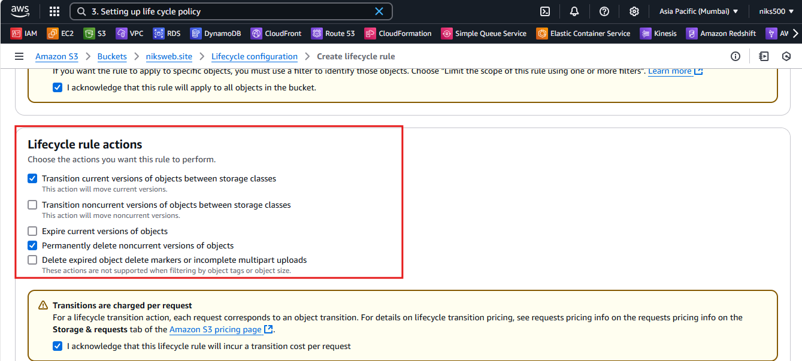

* + **Expiration actions**: Choose to delete objects after a certain number of days. For example, you can delete objects 180 days after they are created.

1. **Configure Expiration:**
   * **Delete objects after X days**: You can set the number of days after which S3 should automatically delete the objects. For example, **180 days**.

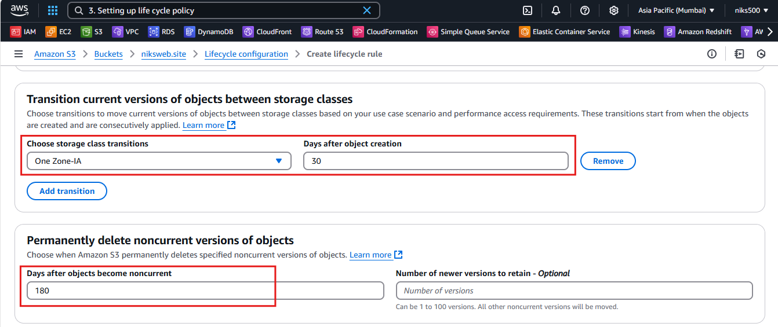

1. **Review and Create:**
   * Review the policy and click **Create rule** to enable the lifecycle policy.

